3.2 Software Architecture Design

3.2.1 Use Case View

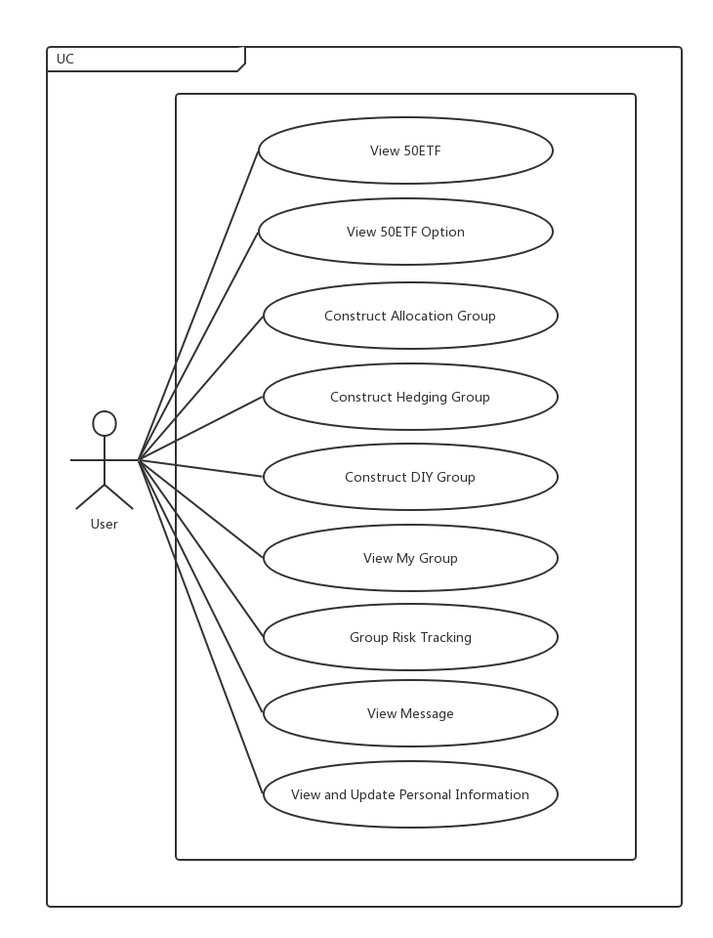

3.2.2 Logical View

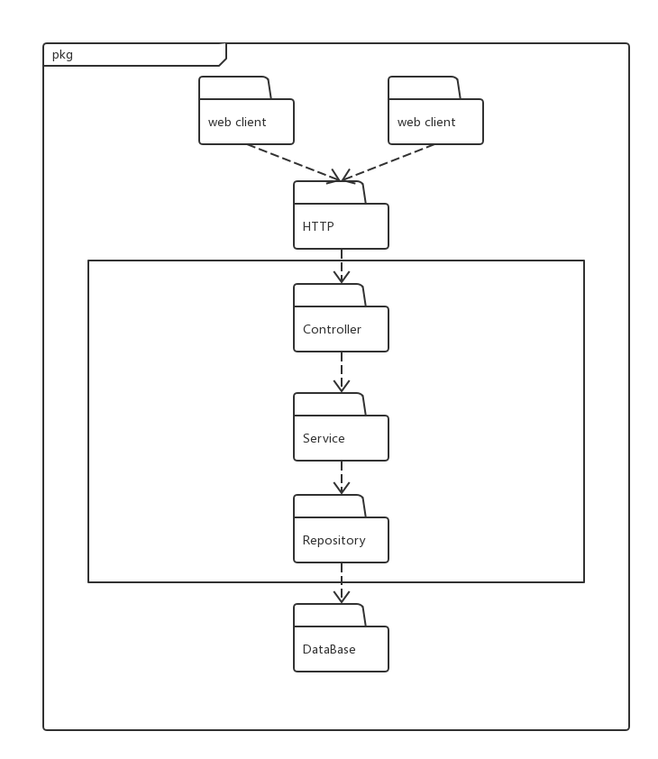

The system adopts the architecture of the interface layer-logic layer-data layer. The client first sends the HTTP requests, and the server's control end receives the requests sent by the client, calling the interfaces of the corresponding modules, and each module processes its own business logic, thus realizing the functional requirements and returning them to users. The data between the client and the server is sent in the form of JSON. The logic layer can obtain data from corresponding interfaces and at this time the data layer sends the requirements downward to the respective data modules for processing. The three layers cooperate with each other to achieve the functional requirements and non-functional requirements of users.

3.2.3 Development View

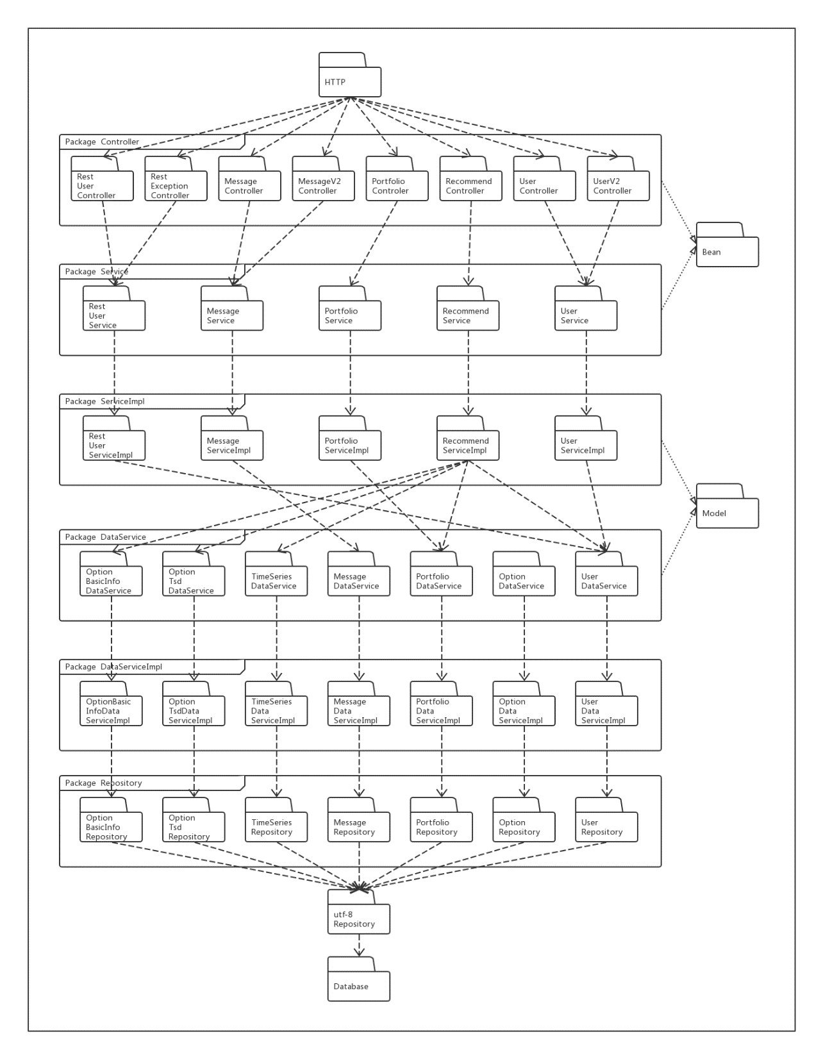

3.2.4 Process View



3.2.5 Deployment View

